**CSE523: Machine Learning**

**Project Progress Report**

**Breast Cancer Detection**

**Group:  The Curators**

|  |  |
| --- | --- |
| **Name** | **Roll number** |
| **Harsh Patel** | **AU1940114** |
| **Kavan Desai** | **AU1940126** |
| **Sarthak Bharad** | **AU1940176** |

**Work done this week:**

* Worked on Feature importance defining the feature importance based on the correlation. We used the threshold value as 0.75
* Implemented Knn using the important feature gained from the above EDA.
* Confusion matrix shows 98% precision and found an increased accuracy score that is 97.872%
* The features where decreased to 16 out of 31 features in total

**Outcomes of the work done:**

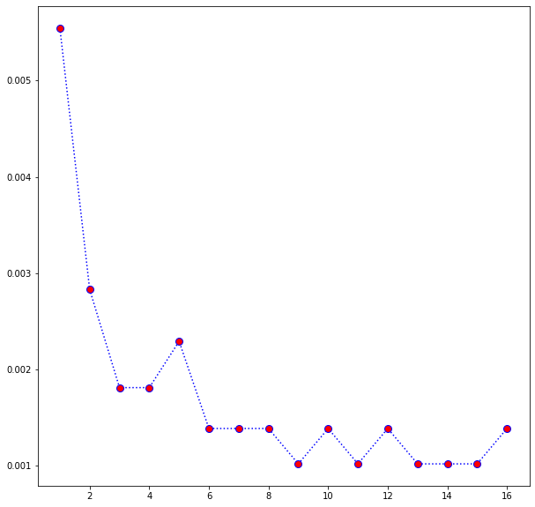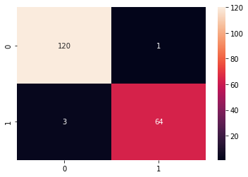

**LINK:-** [**GoogleCollab**](https://colab.research.google.com/drive/1-mlAUkQt--MynKE7K-UQZdrDHUvlg2xK)

**Future work:**

We will implement random forest classification and will try to find different methods of feature importance.